**Linux user management**

If we want to create USER, MODIFY USER, DELETE USER then it is mandatory that we have a **root user** or **superstar**.

**Types of User:-**

* **Super User**

Super-User = ROOT USER

By default fix – >**UID**=0, **GID** = 0

* **System User**

System –user = dhcp, dns, samba, nfs, apache

* **Normal User**

Normal-User = we create like – Satyam, Tripathi, Aman

**Create a root user command :-**

**ubuntu@ip-172-31-4-82:~$** sudo su

Because the **root user** has permission to do anything.

If we want to check this is root user or not we use this command

**ubuntu@ip-172-31-4-82:~$** id

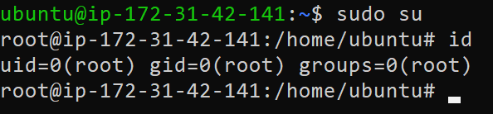

In root user UID and GID both value is come in zero

**UID means** =user-id, **GID Means** = group-id

**We use this command to create new user**

**root@ip-172-31-42-141:/#** useradd satyam

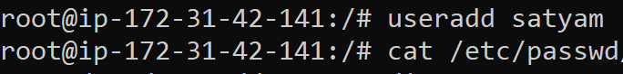

**if we want to check our user we use this command :-**

**root@ip-172-31-42-141:/# cat /etc/passwd**

Go down and check it is visible.

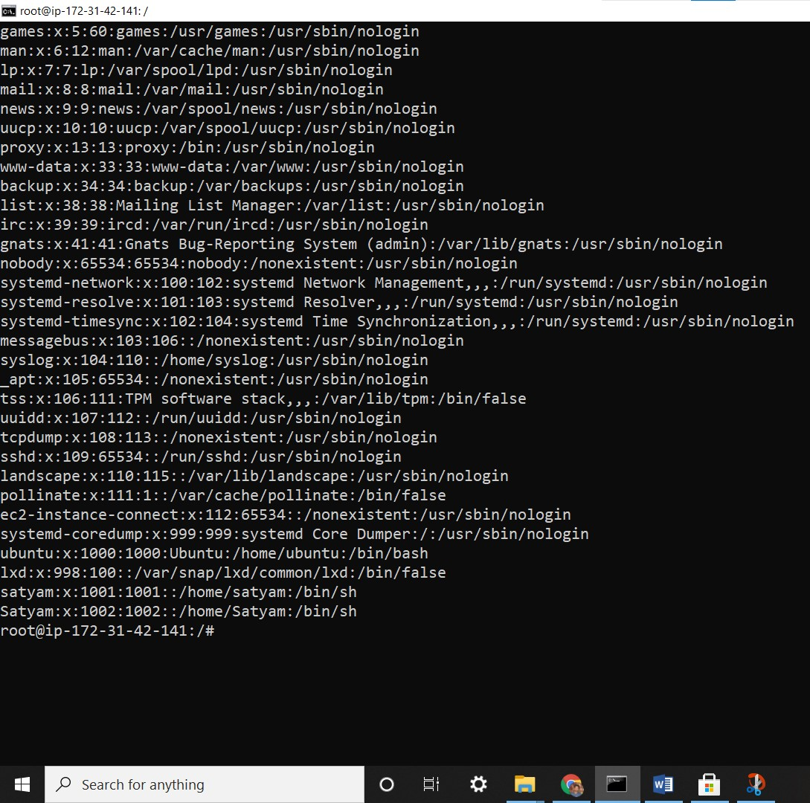

**Satyam:x:1002:1002::/home/satyam:/bin/sh**

**UID GID**